**Comparing based on the descriptive fit of the data**

We have run the regression models using each individual expert’s estimates as input.

R Squared: The proportion of the variance of the target variable that is predictable from the feature variables. On calculating the R Squared value, we see that the Illy model has the smallest R squared value.

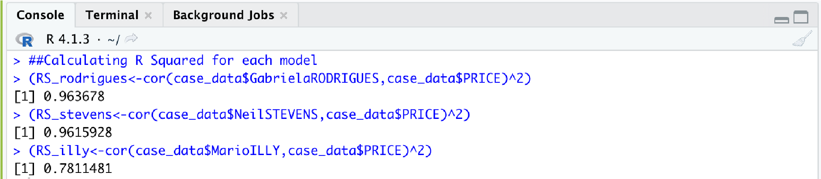

The main purpose of a model prediction is to make an accurate prediction. We have compared the three individual expert models and noted that the Illy model had the least precise prediction.

**Comparing based on multiple regression models**

We then went on to analyze the fit of multiple regression models using two expert’s estimates. We have run the multiple regression models for scenarios where we fire one of the coffee experts:

We ran multiple regression models assuming we fire RODRIGUES, assuming we fire STEVENS, and assuming we fire ILLY respectively below:

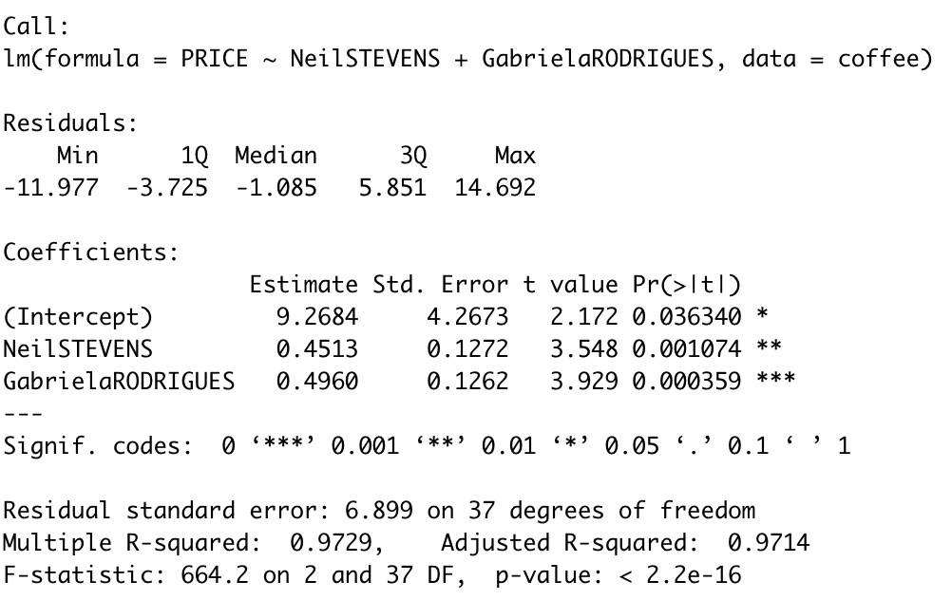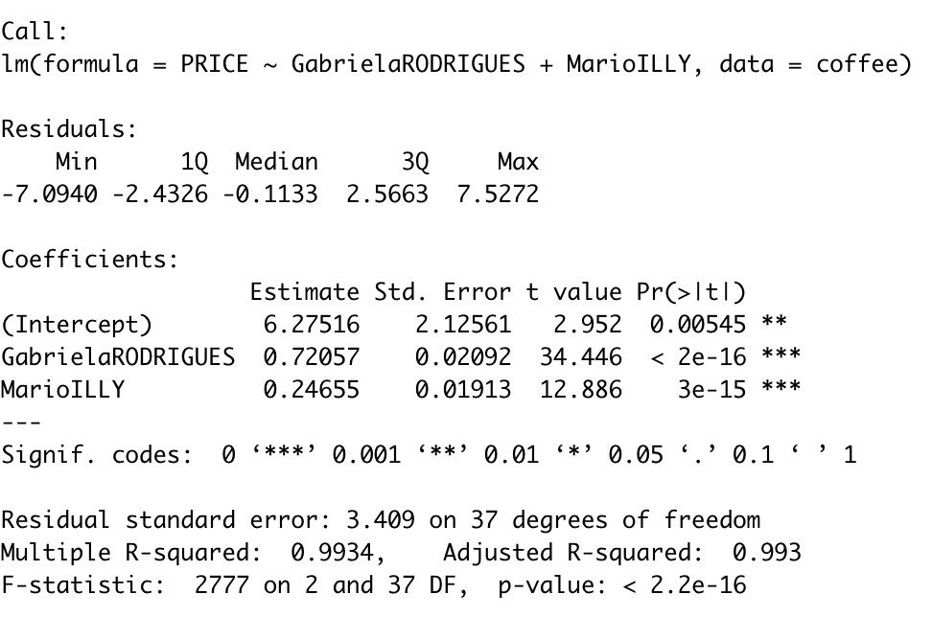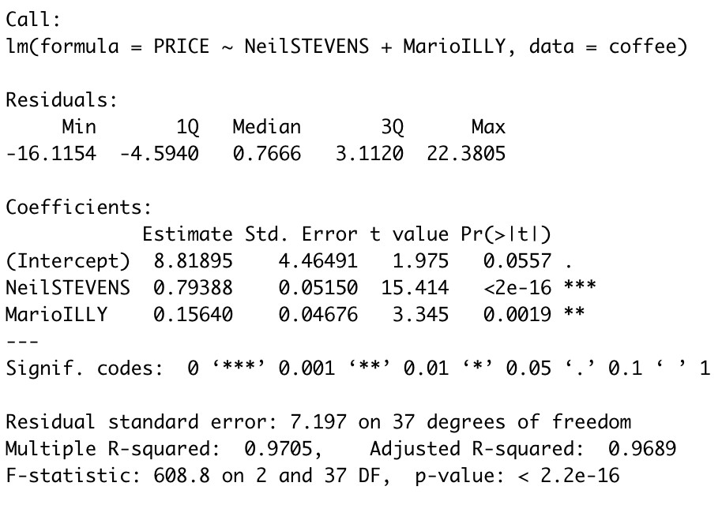

From the output of the three combined models, we see that the model in which we fire Steven’s has the highest R square value of 0.9934. This means that the model better fits the data. This might be the case because Rodrigues and Illy have the lowest correlation at 0.793 and might offer different perspectives that can produce the most accurate estimates when combined. Thus, we suggest that Stevens is not required.

We reckon that combining the forecasts can be done by combining the independent forecasts and creating one composite forecast using the two based on the accuracy of each (weights). This can help improve accuracy by reducing errors that can arise from predictions based on incorrect assumptions, any inherent bias, or data entry errors. We can use multiple regression to find the linear model that best fits the actual coffee prices with the forecasts from Stevens and Illy.

From the analysis performed earlier, we noted that Neil Stevens’ model is more accurate, we would give it a higher weightage than Mario Illys’ model. Hence, our prediction would be closer to 210.15c than 250.20c. On creating and running our multiple regression model, we get a fit of 214.78 which is in line with the statement above.

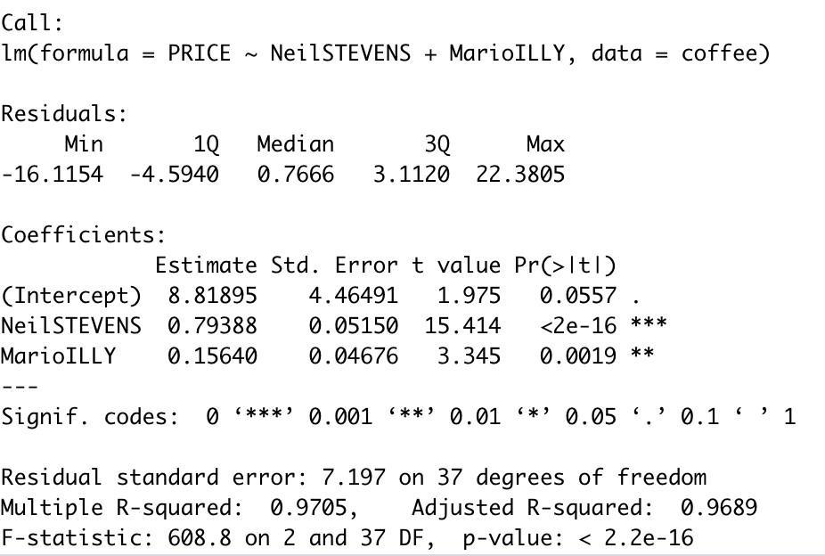

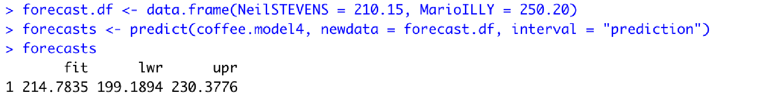

**Our Advice:**

1. We would advise combining forecasts derived from methods that differ substantially and draw from different sources of information. We would also advise the experts to be unbiased and objective and to work independently so as to make sure that they bring in different perspectives. This can lead to more creativity and help to reduce risks.
2. Since there is a dearth of past performance data, we would recommend surveying past customers and conducting market research in order to gain a better understanding of the movement of customer choices as well as supply fluctuations.